SMART CITY COMPLAINT ANALYTICS DASHBOARD
By: Madumitha M
Problem Statement
Modern cities receive many citizen complaints about garbage collection, water supply problems, damaged roads, street light problems, traffic problems, drainage issues, etc. It is difficult for cities to monitor and resolve these complaints due to increasing complaints and increasing complexity in their work. Therefore, this project will focus on the analysis of data related to complaints and design a smart city complaint analytics dashboard.
Data Set Information
The Smart City Complaint Data set includes details of the complaint and resolution details.
Key Columns Selected
- Complaint ID
- Complaint Date
- Complaint types
- Department
- Complaint priority
- Severity Level
- Statuses
- resolution days
Calculated Measures Created
- Resolved Complaints
- Resolution Rate
- Average resolution time
- High Priority Complaints
- Citizen Satisfaction Score
- Complaint Hotspot Zones
- Departmental performance score

Key Performance Indicators (KPIs)
Following KPIs have been developed to keep track of city operations.
- Total Complaints: Total complaints received
- Resolved Complaints: Resolved complaints
- Resolution rate: Resolution rate percent
- Average resolution time: Days taken to resolve complaints
- High Priority Complaints: Complaints requiring immediate action
- Citizen satisfaction score: Citizen satisfaction level
- Complaint Hotspot zones: Departments/locations with high complaints
- Department performance score: Departmental performance level

Screenshots of Dashboards
Executive Overview
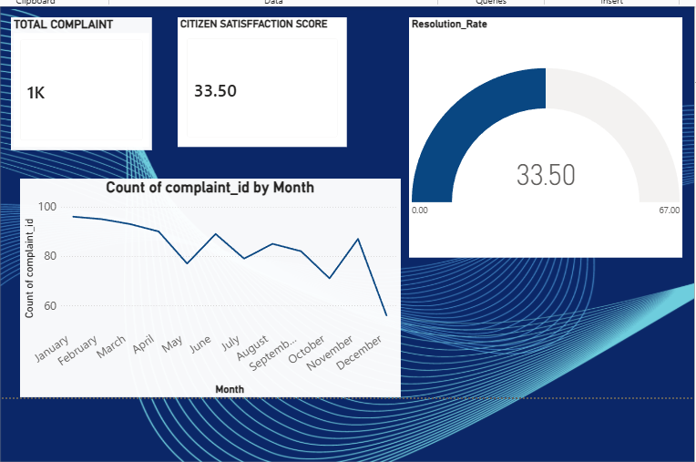
This dashboard provides a snapshot of the number of total complaints, their resolution rates, citizen satisfaction scores, and trends in complaint cases.

Complaint Dashboard

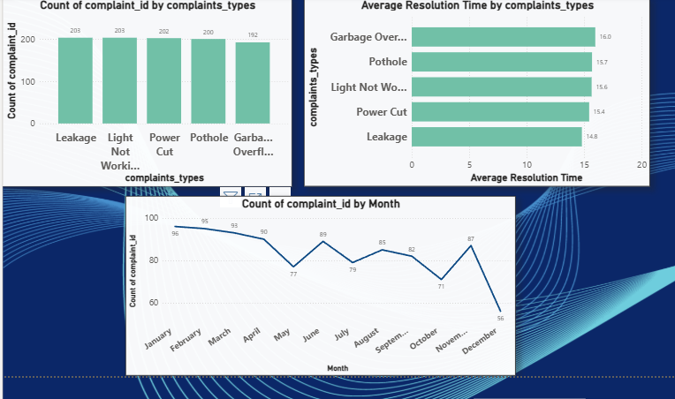
This dashboard is useful for analyzing complaints based on their category, trend, and rate of resolution.
Service Performance Dashboard
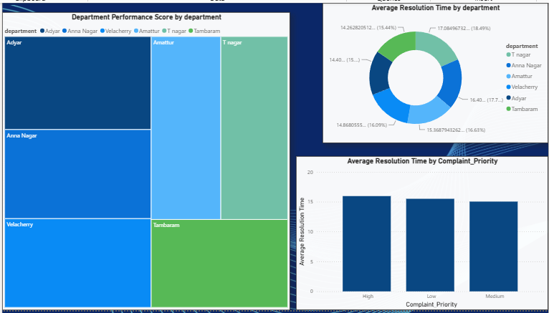
This dashboard helps evaluate the performance of departments, efficiency in resolving complaints, and prioritizing complaint resolution.

Key Insights Obtained
- The most common complaint category found was that of Garbage Overflow with a total of 16 complaints.
- Trend analysis of complaints helped in identifying regular civic problems.
- Efficiency rates differed from one department to another.
- Higher-priority complaints demanded quicker action and resolution.
- The dashboard provided valuable insights to enhance city service performance.
Recommendations
Enhance garbage management facilities to decrease Garbage Overflow complaints.
Prioritize quick resolution of complaints with high priority.
Improve the performance of slower responding departments.
Identify recurring civic problems through trend analysis of complaints.
Utilize dashboard insights for decision-making purposes.
Future Scope
The possible improvements that can be made in the future include:
- Real-time integration of complaint data.
- Analysis for forecasting the number of complaints.
- Development of apps for citizens to track complaints.
- Automated alerts for highly prioritized complaints.
- Geospatial analysis for better urban planning.
Innovations
The dashboard combines multiple KPIs, complaint trend analysis, performance management, and business recommendations within an interactive platform using visual analytics.
Conclusion
The Smart City Complaint Analytics Dashboard has been effective in analyzing the complaint data and providing meaningful results. This will help in making civic services more efficient.

